COIT20259 - Enterprise Computing Architecture

Term 1, 2020

Assignment 2 - Team-based Enterprise Application Development Project

Lecture: Baloch, Muhammad Ismail

Tutor: Singh, Prabhu Jyot

**Team Details:**

Aman Kumar Maharjan (Leader) - 12102452

Tammy Kanashiro – 12100880

Damodar Chaulagain – 12099970

Table of Content

Diagram of Architecture 3

Workflow 3

End User Manual and Test Instruction 20

# Diagram of Architecture

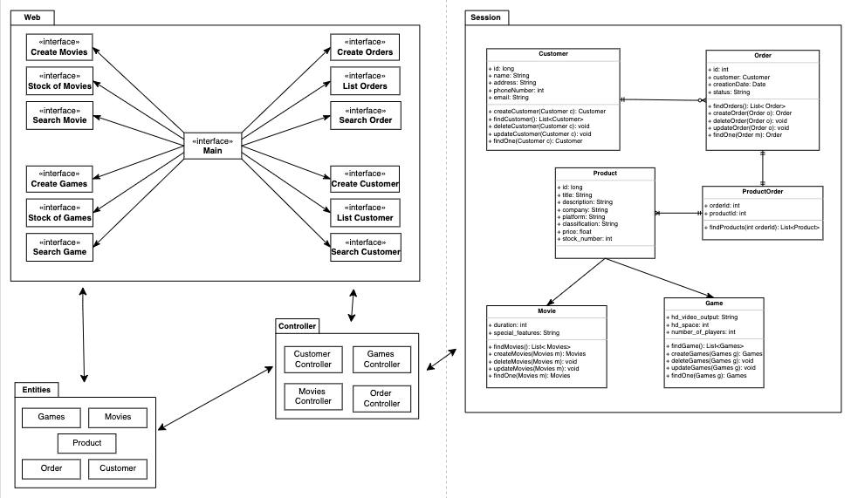

Figure 1: Diagram

# Workflow

**1) Main Page**

The main page has nine buttons, which the user can select his / her action (See Figure 2 and Figure 3).

|  |  |
| --- | --- |
| **Action** | **Details** |
| Create new customer | Go to new customer page |
| List all customers | Go to list of customers page |
| Search for customer | Go to search customer page |
| Create new order | Go to new orders page |
| List all orders | Go to list of orders page |
| Search for order | Go to search order page |
| Create new game | Go to new game page |
| Check the stock of games | Go to stock of games page |
| Search for a game | Go to search game page |
| Create new movie | Go to new movie page |
| Check the stock of movies | Go to stock of movies page |
| Search for a movie | Go to search movie page |

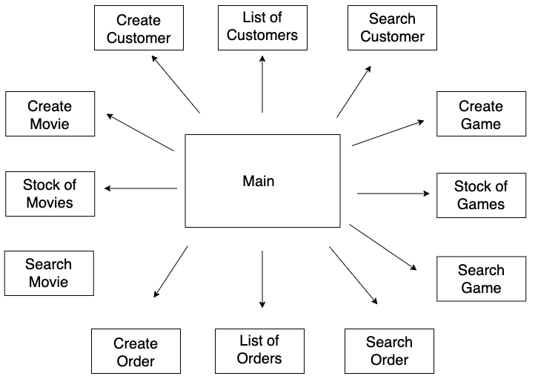

Figure 2: Main Page Workflow

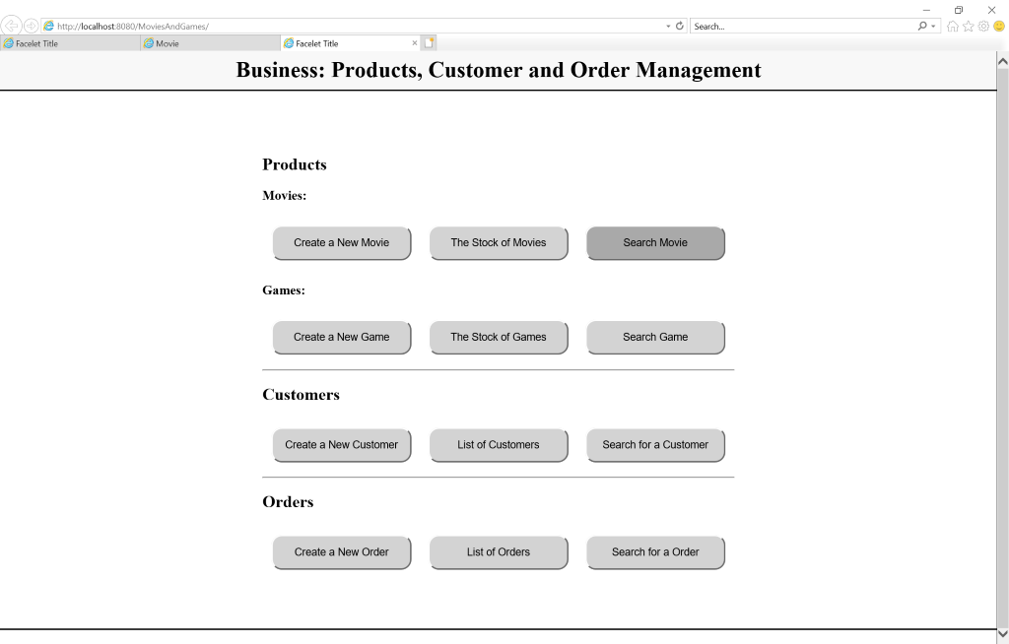

Figure 3: index.html

**2) Movies**

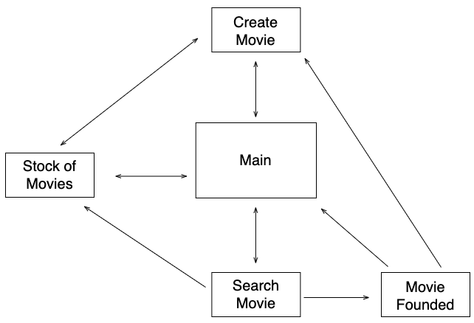

Figure 4: Movie Workflow

**2.1) Create a New Movie**

User can create a new movie, inserting movie title, description, company, platform, classification, price, stock number, duration and special features (Figure 5). After movies is created, the system returns confirmation page (Figure 6).

|  |  |
| --- | --- |
| **Action** | **Details** |
| Create a Movie | Users must enter with all movie details. |
| The Stock of Movies | Go to stock movies page |
| Main Page | Go to main page |

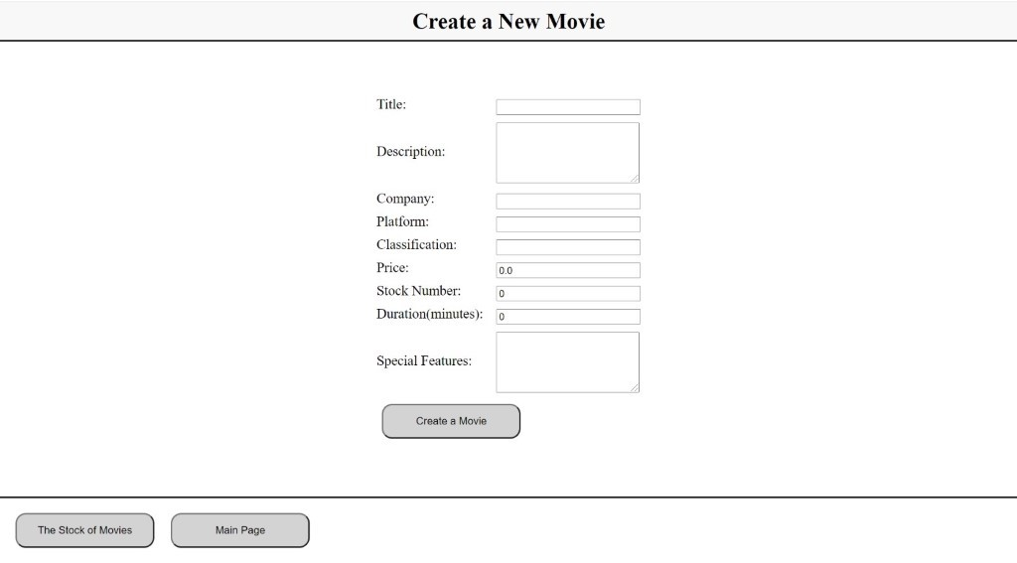

Figure 5: Create Movie Page

|  |  |
| --- | --- |
| **Action** | **Details** |
| Create a New Movie | Go to new movie page |
| Main page | Go to main page |

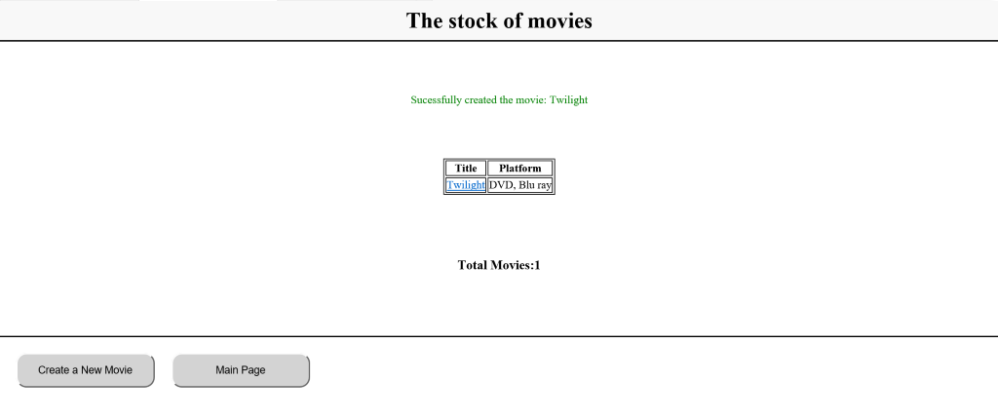

Figure 6: Create Movie Success

**2.2) The Stock of Movies**

This page returns all movies available in stock. It displays the movie title and platform (Figure 7).

|  |  |
| --- | --- |
| **Action** | **Details** |
| Create a New Movie | Go to new movie page |
| Main page | Go to main page |

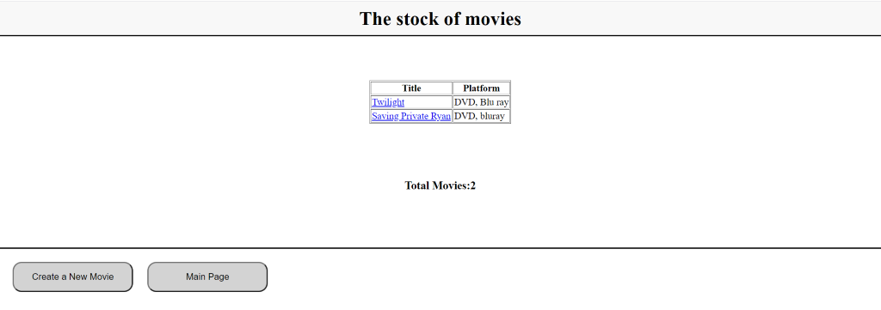

Figure 7: Stock of Movies Page

**2.3) Search Movie**

User can search for a specific movie by title (Figure 8). The system returns a new page with movie details (Figure 9).

|  |  |
| --- | --- |
| **Action** | **Details** |
| Search a Movie | User must enter movie title |
| Create a New Movie | Go to new movie page |
| Main page | Go to main page |

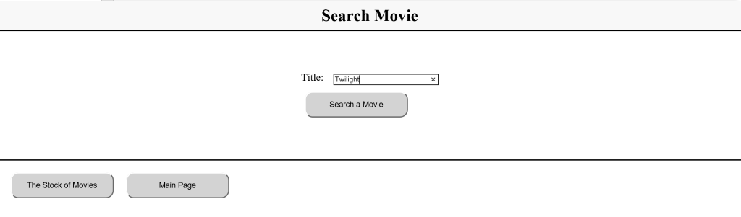

Figure 8: Search Movie Page

|  |  |
| --- | --- |
| **Action** | **Details** |
| Create a New Movie | Go to new movie page |
| Main page | Go to main page |

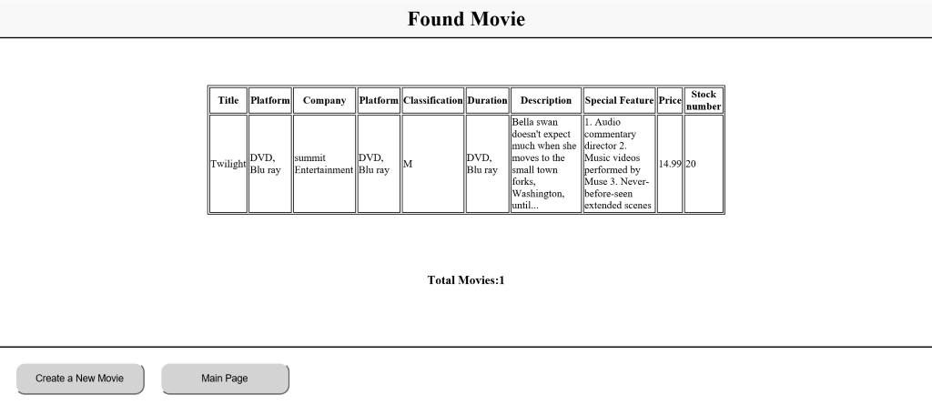

Figure 9: Movie Result Page

**3) Games**

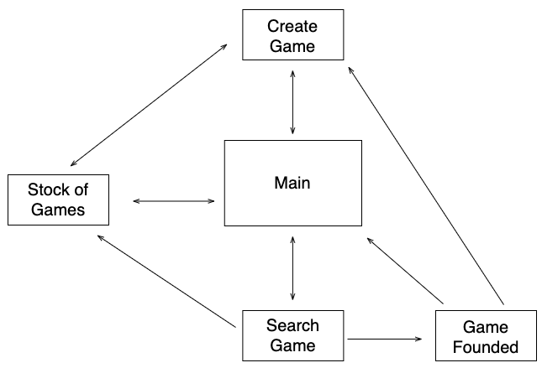

Figure 10: Game Workflow

**3.1) Create a New Game**

User can create a new game, inserting game title, description, company, platform, classification, price, stock number, HD video output, HD space and number of players (Figure 11). After game is created, the system returns confirmation page (Figure 12).

|  |  |
| --- | --- |
| **Action** | **Details** |
| Create a Game | User must enter with all game details |
| The Stock of Games | Go to stock game page |
| Main Page | Go to main page |

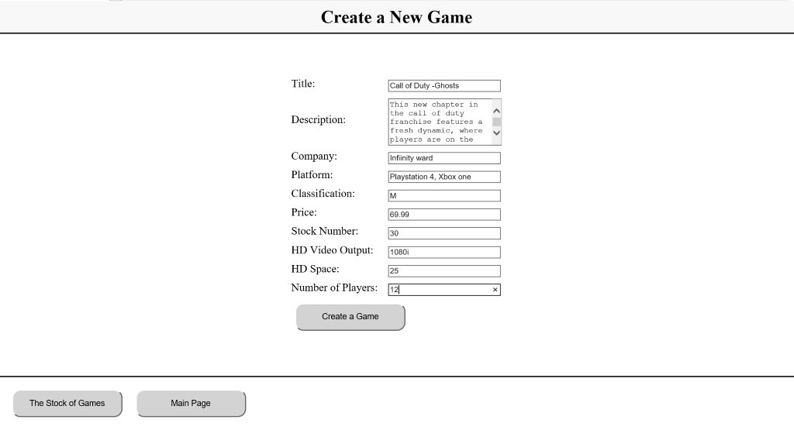

Figure 11: New Game Page

|  |  |
| --- | --- |
| **Action** | **Details** |
| Create a New Games | Go to new game page |
| Main Page | Go to main page |

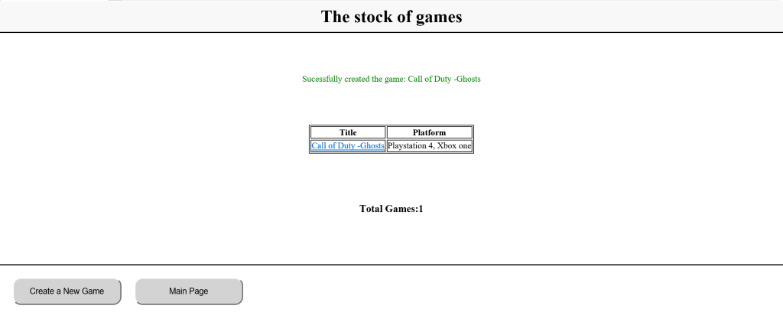

Figure 12: New Game Success

**3.2) The Stock of Games**

This page returns all games available in stock. It displays the game title and platform (Figure 13).

|  |  |
| --- | --- |
| **Action** | **Details** |
| Create a New Games | Go to new game page |
| Main Page | Go to main page |

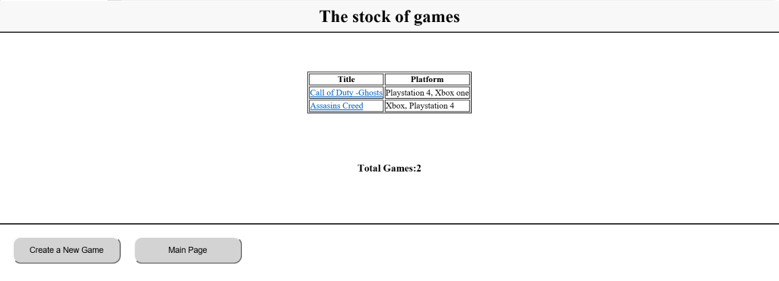

Figure 13: Stock of Games

**3.3) Search Game**

User can search for a specific game by title (Figure 14). The system returns a new page with game details (Figure 15).

|  |  |
| --- | --- |
| **Action** | **Details** |
| Search a Game | User must enter game title |
| The Stock of Games | Go to stock game page |
| Main Page | Go to main page |

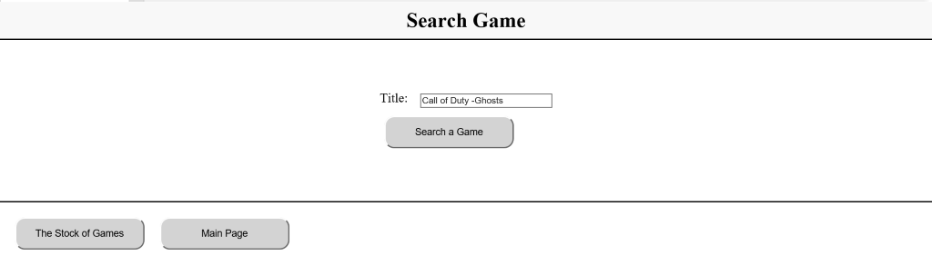

Figure 14: Search Game Page

|  |  |
| --- | --- |
| **Action** | **Details** |
| Create a New Games | Go to new game page |
| Main Page | Go to main page |

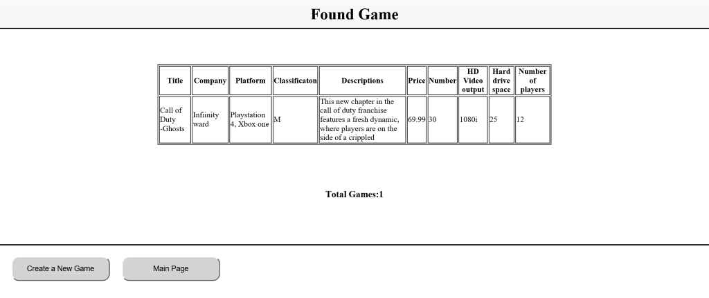

Figure 15: Game Result Page

**4) Customers**

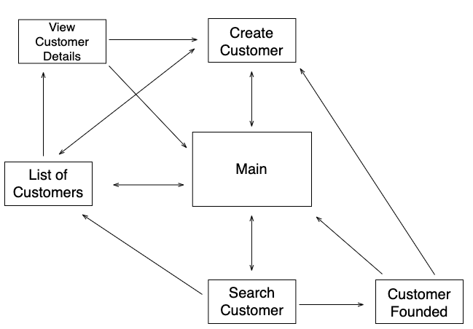

Figure 16: Customer Workflow

**4.1) Create a New Customer**

User can create a new customer, inserting customer name, address, phone number and e-mail address (Figure 17). After customer is created, the system returns confirmation page (Figure 18).

|  |  |
| --- | --- |
| **Action** | **Details** |
| Create a Customer | User must enter with all customer details |
| List of Customer | Go to customer list page |
| Main Page | Go to main page |

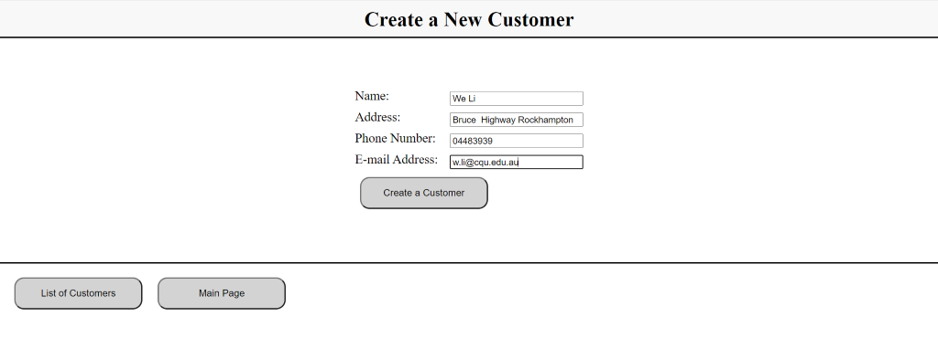

Figure 17: New Customer Page

|  |  |
| --- | --- |
| **Action** | **Details** |
| View Details | See topic 4.4 for more details |
| Create a New Customer | Go to new customer page |
| Main Page | Go to main page |

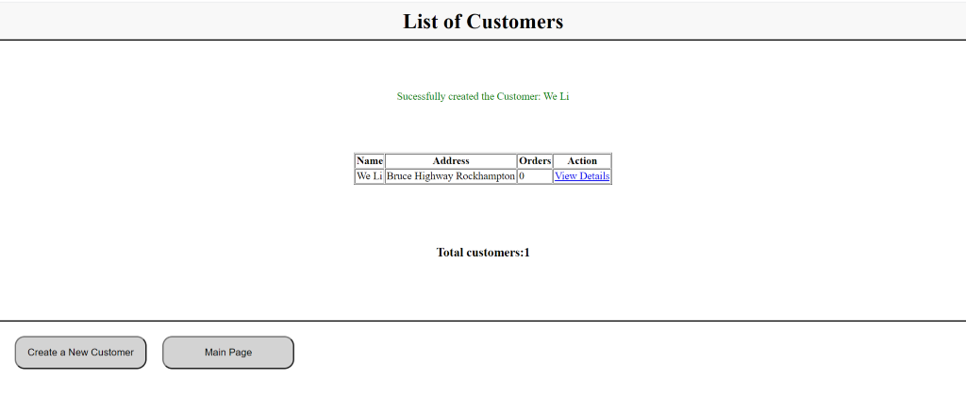

Figure 18: New Customer Success

**4.2) List of Customers**

This page returns all customer registered on database. It displays the customer name, address and order (Figure 19).

|  |  |
| --- | --- |
| **Action** | **Details** |
| View Details | See topic 4.4 for more details |
| Create a New Customer | Go to new customer page |
| Main Page | Go to main page |

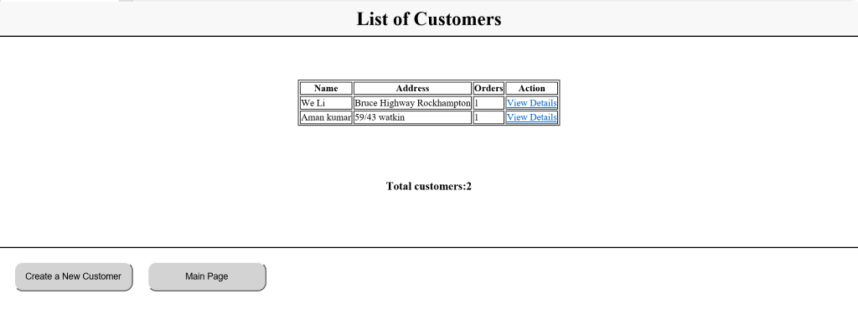

Figure 19: List of Customers Page

**4.3) Search Customer**

User can search for a specific customer by name (Figure 20). The system returns a new page with customer details (Figure 21).

|  |  |
| --- | --- |
| **Action** | **Details** |
| Search a Customer | User must enter customer name |
| List of Customer | Go to customer list page |
| Main Page | Go to main page |

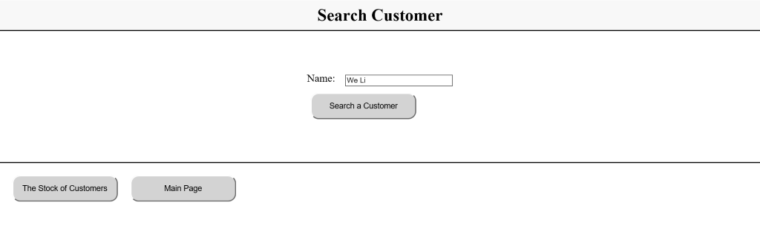

Figure 20: Search Customer Page

|  |  |
| --- | --- |
| **Action** | **Details** |
| View Details | See topic 4.4 for more details |
| Create a New Customer | Go to new customer page |
| Main Page | Go to main page |

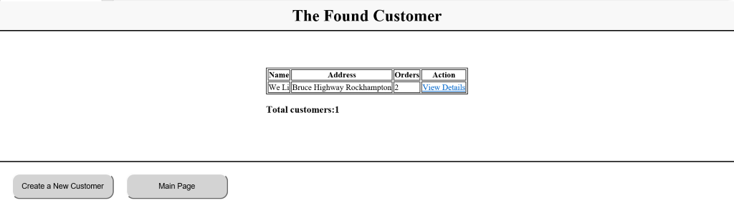

Figure 21: Customer Result Page

**4.4) Customer Details**

Figure 18, Figure 19 and Figure 21 show View Details action for the list. It opens a new page with all customers information and order related (Figure 22).

|  |  |
| --- | --- |
| **Action** | **Details** |
| Create a New Customer | Go to new customer page |
| Main Page | Go to main page |

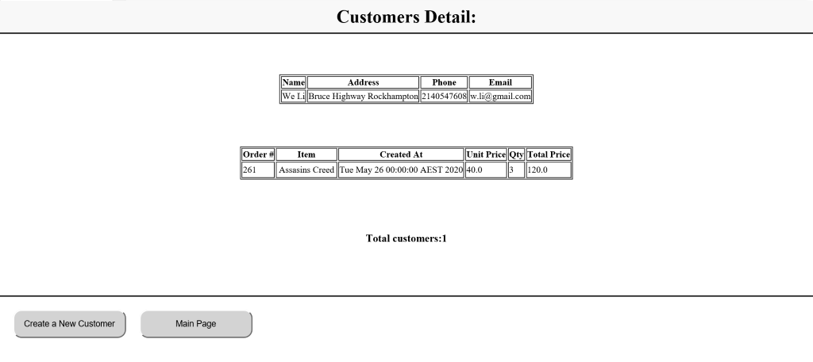

Figure 22: Customers Details

**5) Orders**

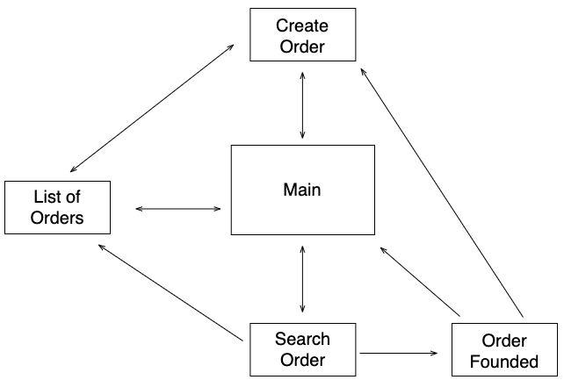

Figure 23: Orders Workflow

**5.1) Create a New Order**

User can create a new order, inserting customer, item and quantity (Figure 24). After order is created, the system returns confirmation page (Figure 25).

|  |  |
| --- | --- |
| **Action** | **Details** |
| Create an Order | User must enter with all order details |
| Order List | Go to order list page |
| Main Page | Go to main page |

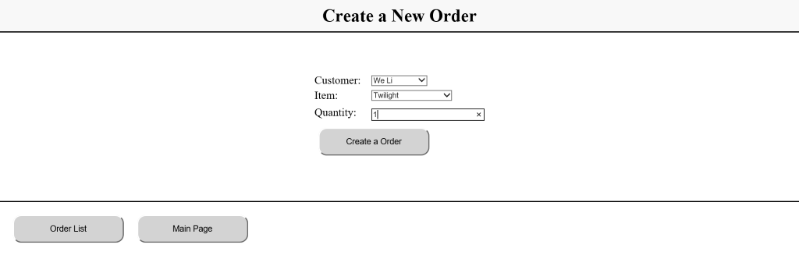

Figure 24: New Order Page

|  |  |
| --- | --- |
| **Action** | **Details** |
| Create a New Order | Go to new order page |
| Main Page | Go to main page |

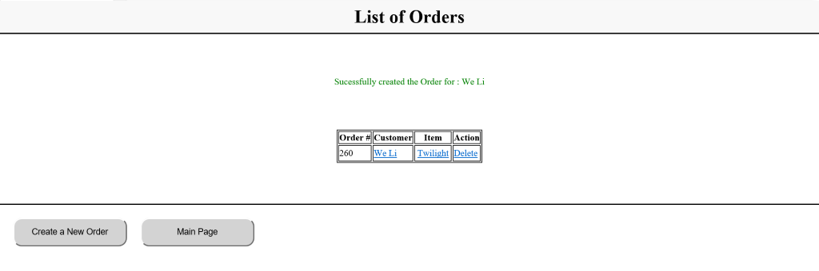

Figure 25: New Order Success

**5.2) List of Orders**

This page returns all orders made. It displays the order number, customer and item required (Figure 26).

|  |  |
| --- | --- |
| **Action** | **Details** |
| Create a New Order | Go to new order page |
| Main Page | Go to main page |

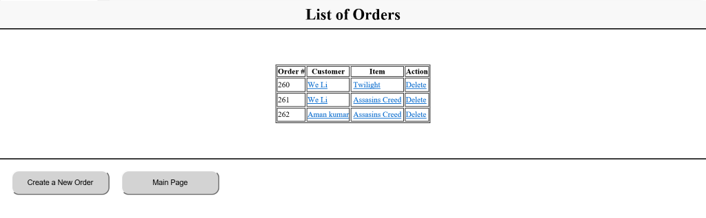

Figure 26: List of Orders Page

**5.3) Search Order**

User can search for a specific order by id (Figure 27). The system returns a new page with order details (Figure 28).

|  |  |
| --- | --- |
| **Action** | **Details** |
| Search for an Order | User must enter order id |
| The stock of Order | Go to order list page |
| Main Page | Go to main page |

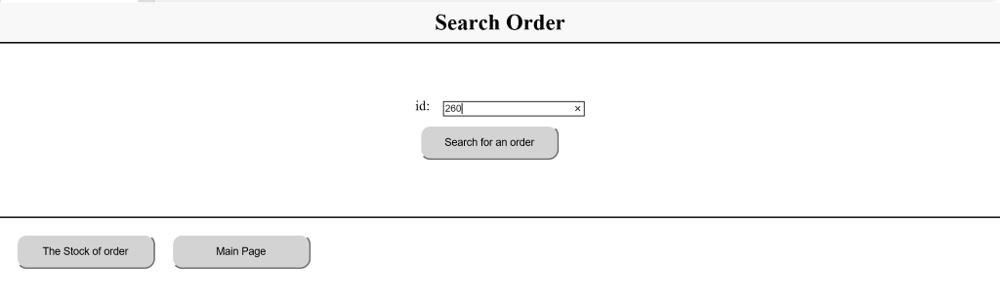

Figure 27: Search Order Page

|  |  |
| --- | --- |
| **Action** | **Details** |
| Create a New Order | Go to new order page |
| Main Page | Go to main page |

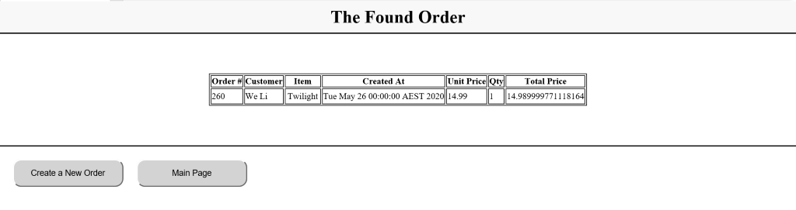

Figure 28: Order Result Page

# End User Manual and Test Instruction

**1.Start Derby**

Make sure derby is installed. Use command “startnetworkserver” in command prompt

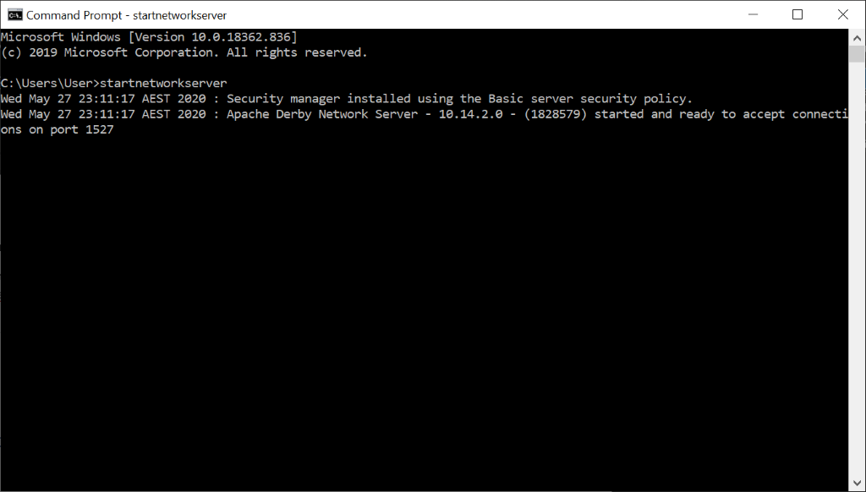

**2.Create database movieandgame**

Right click database and select new connection from the services tab in NetBeans project

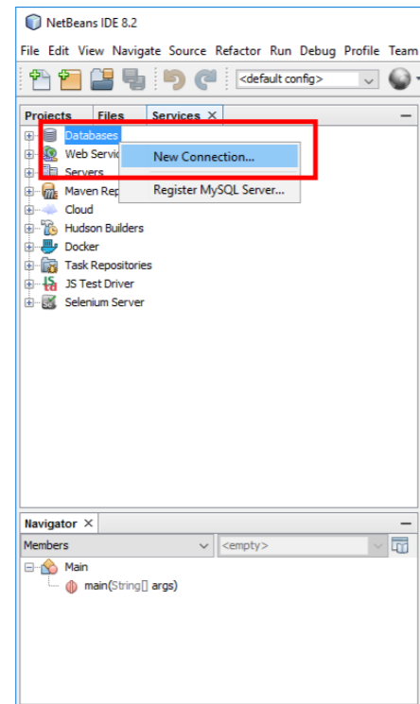

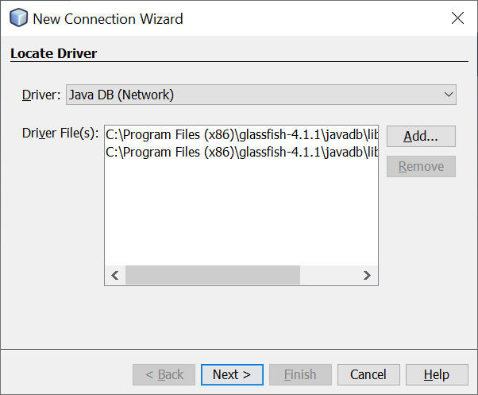

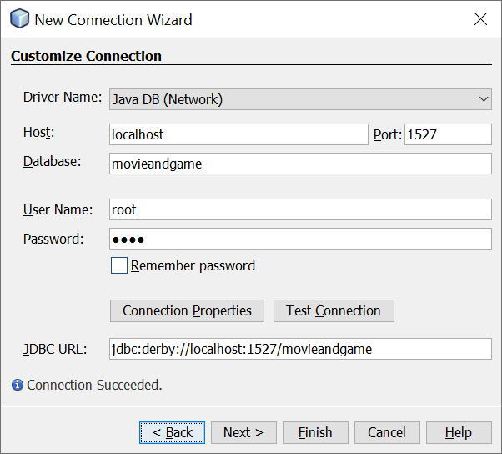

**Enter following details:**

Host: localhost

Port:1527

Databse: movieandgame

Username: root

Password: root

**Select Database:**

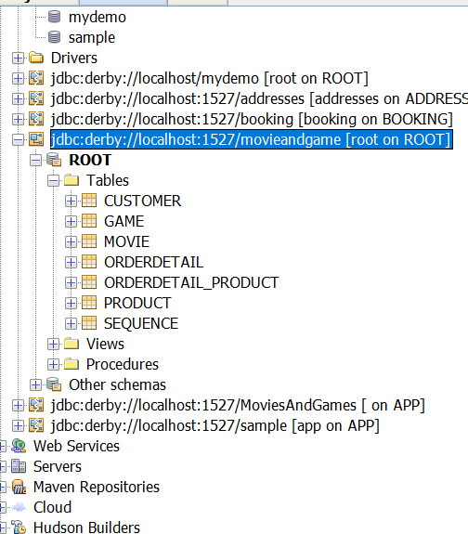

**3.Start the glassfish server:**

Make sure glassfish server is installed. Run as administration on the Command line and enter the following command:

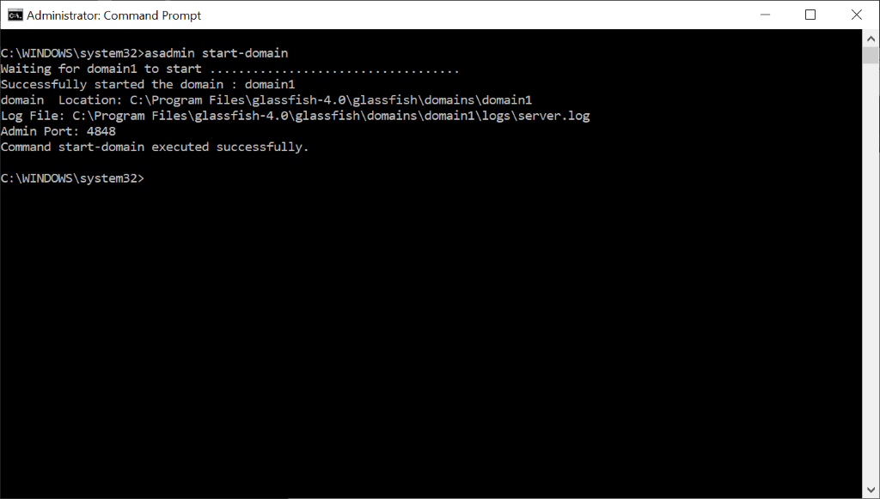

Enter <http://localhost:4848/> in browser and check.

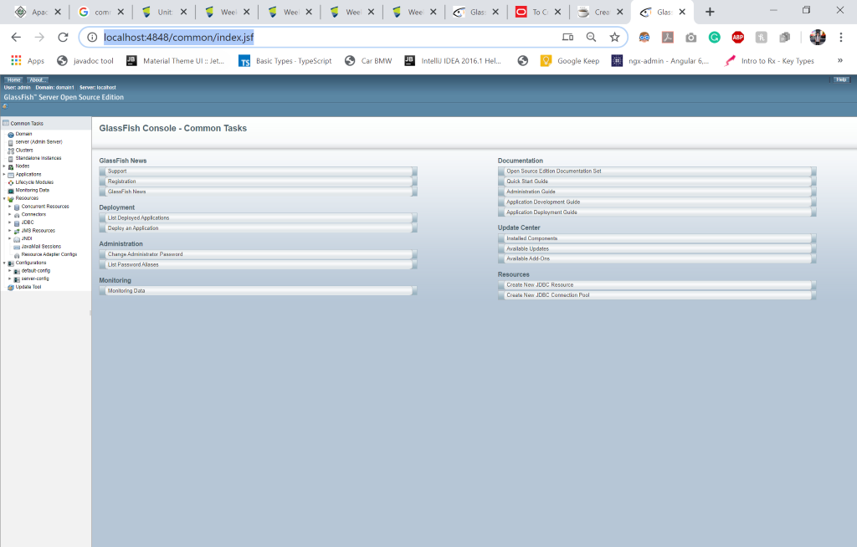

**4. Create Connection Pool**

For creating connection pool, enter the following command in the command line:

asadmin create-jdbc-connection-pool --datasourceclassname=org.apache.derby.jdbc.ClientDataSource --restype=javax.sql.DataSource --property portNumber=1527:password=root:user=root:serverName=localhost:databaseName=movieandgame:connectionAttributes=;create\=true movieandgamepool  
Ping

asadmin ping-connection-pool movieandgamepool

**Create Resource**

asadmin create-jdbc-resource --connectionpoolid movieandgamepool jdbc/movieandgame

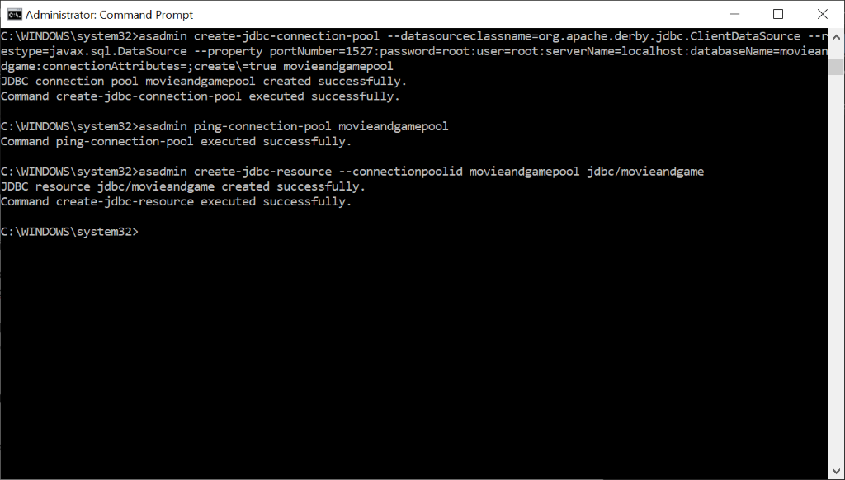

**5.Open Project**

File open the project in NetBeans

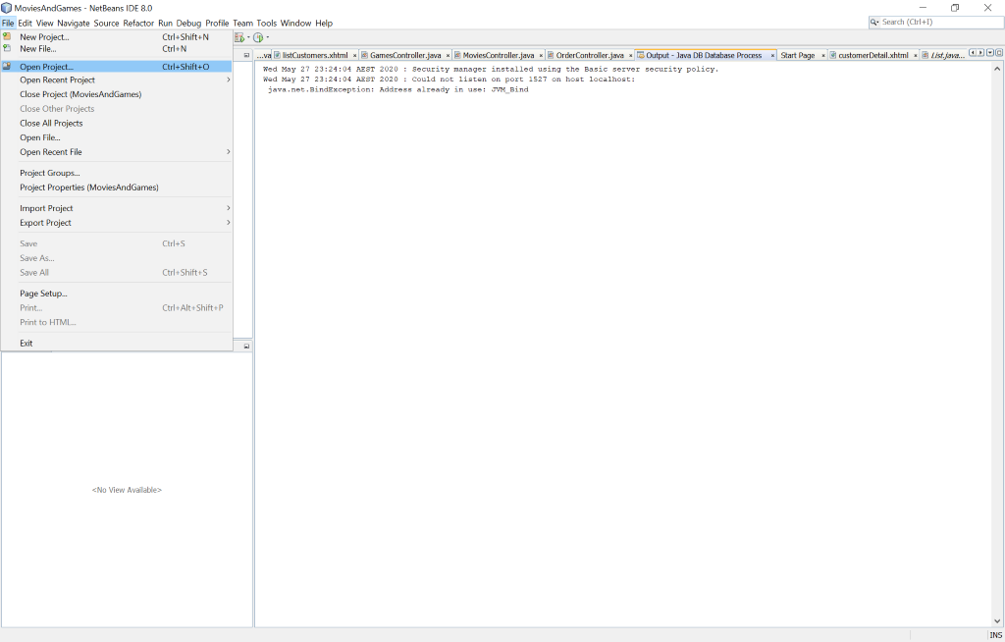

Open the project **MoviesandGames:**

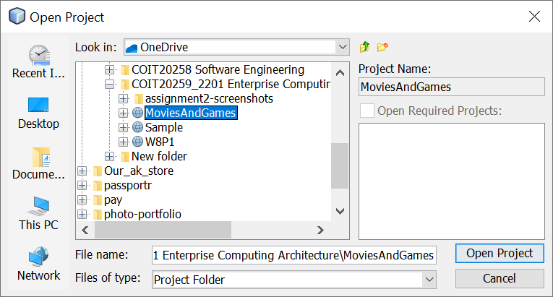

**6.Clean and build the project**

Press clean and build under the Run Menu at the top.

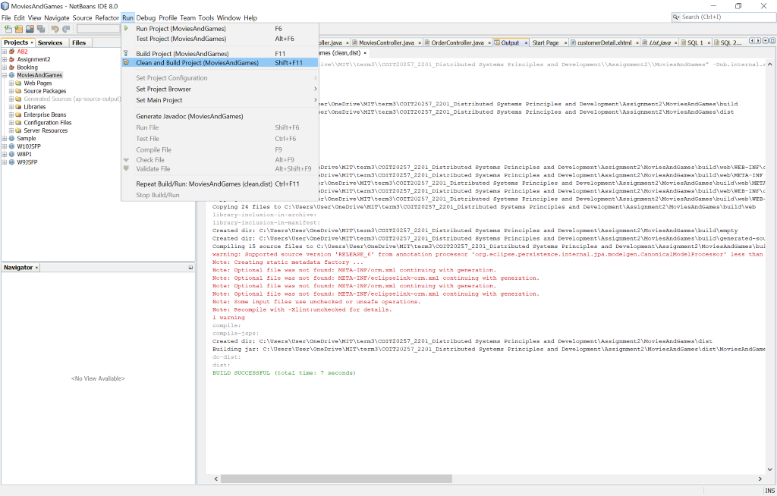

**7.Run the project**

Open glassfish server admin console panel by entering <http://localhost:4848/> in browser.



Go to the application on the left side bar and select deploy.

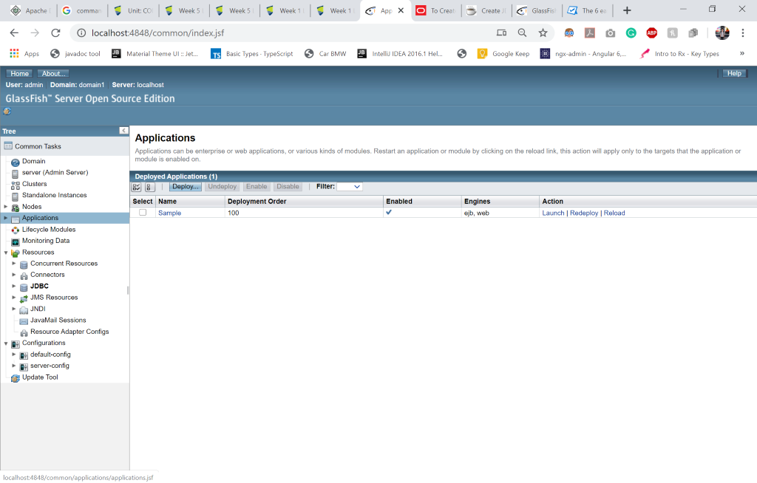

Choose file

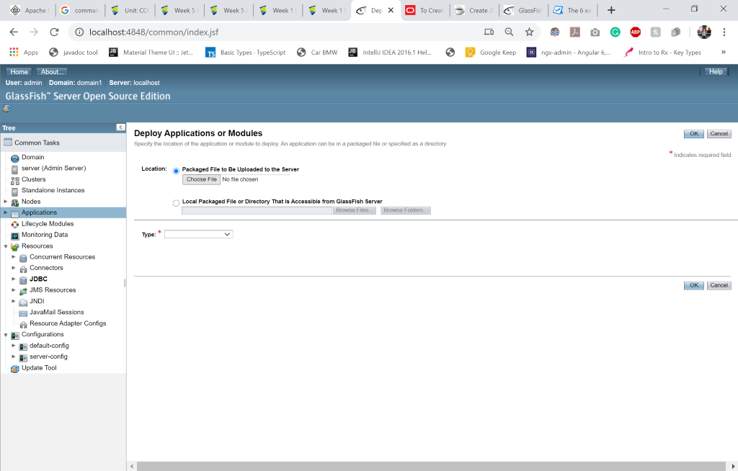

Select the MoviesAndGames.war file from the dist folder of the **moviesandgames** project.

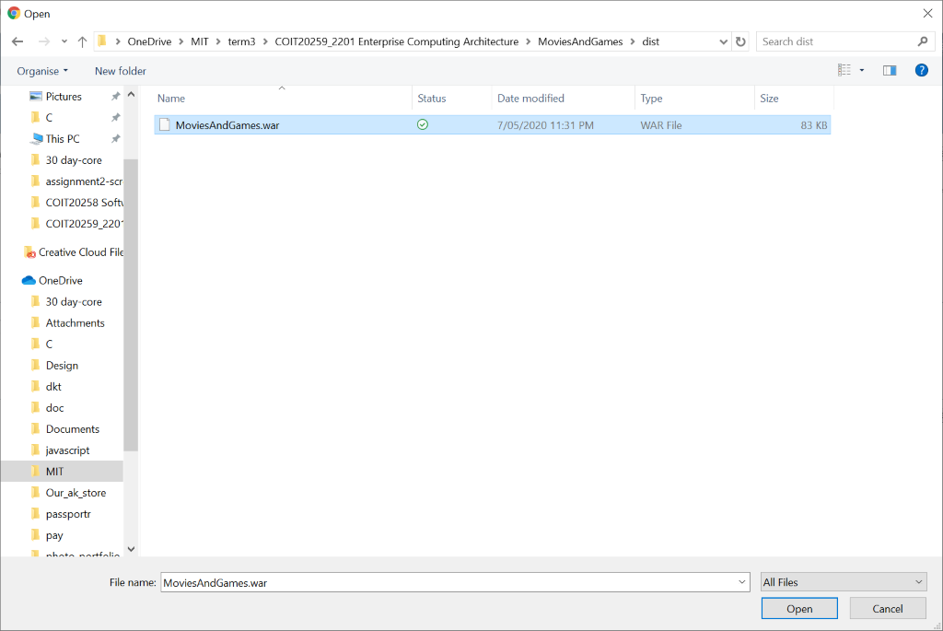

Launch the MoviesAndGames.

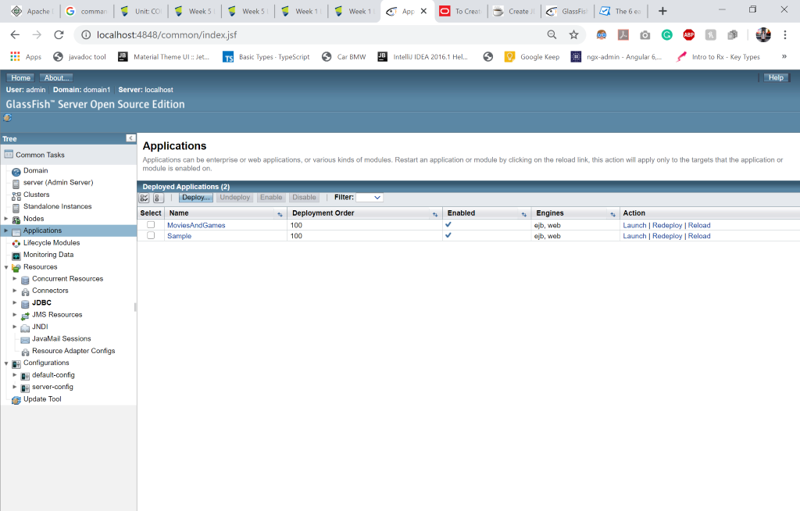

Click on any of the link

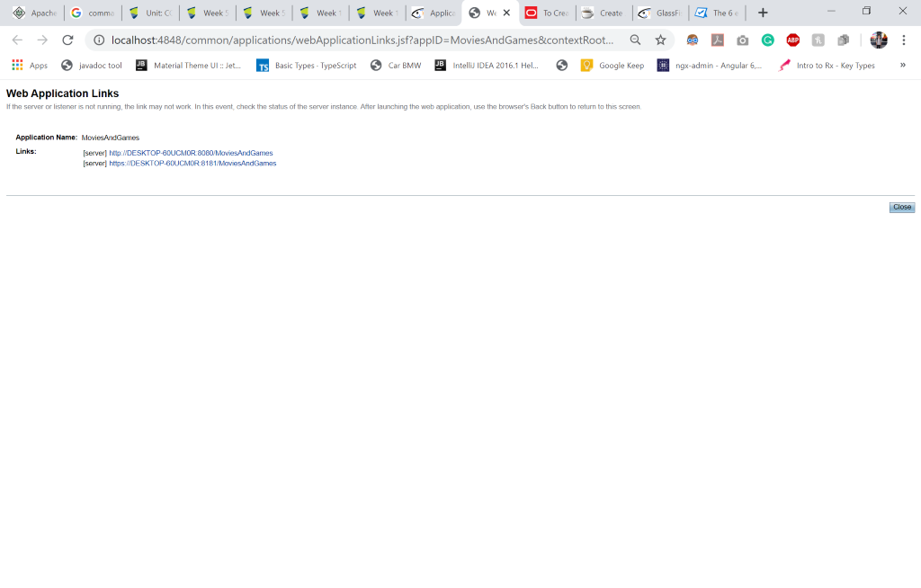

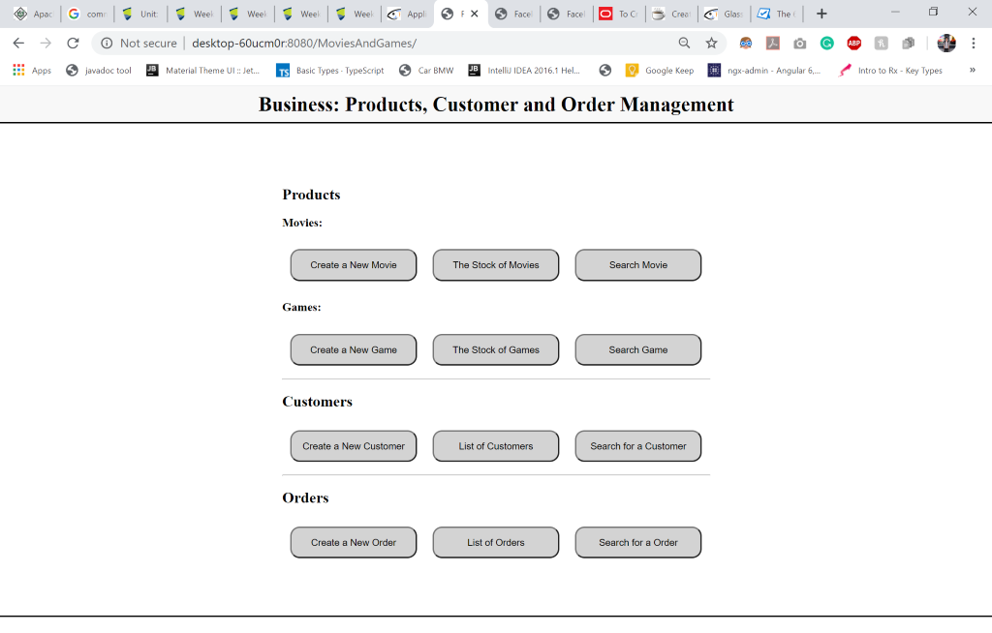

**8.Create 2 Movies**

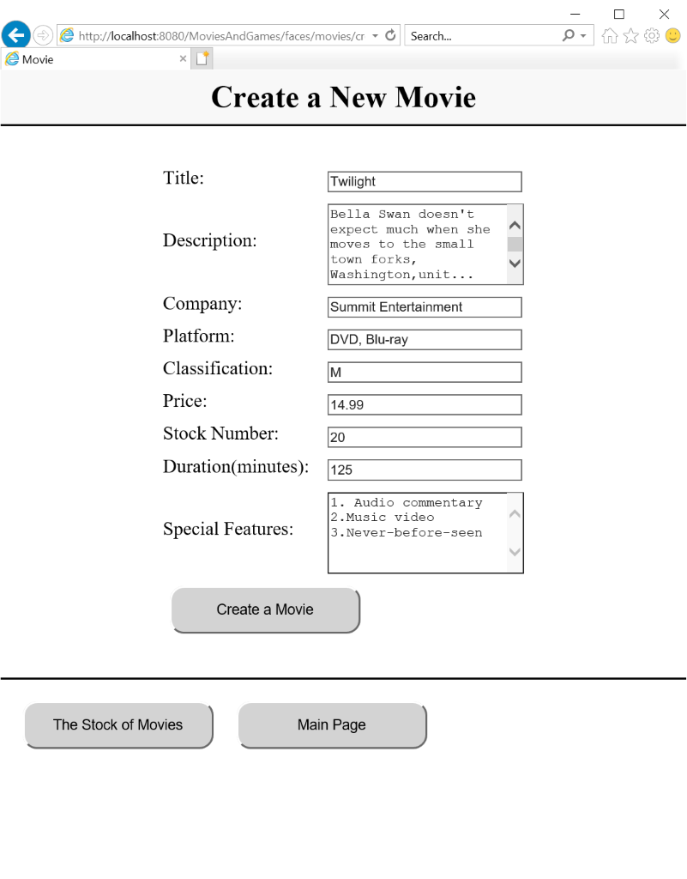

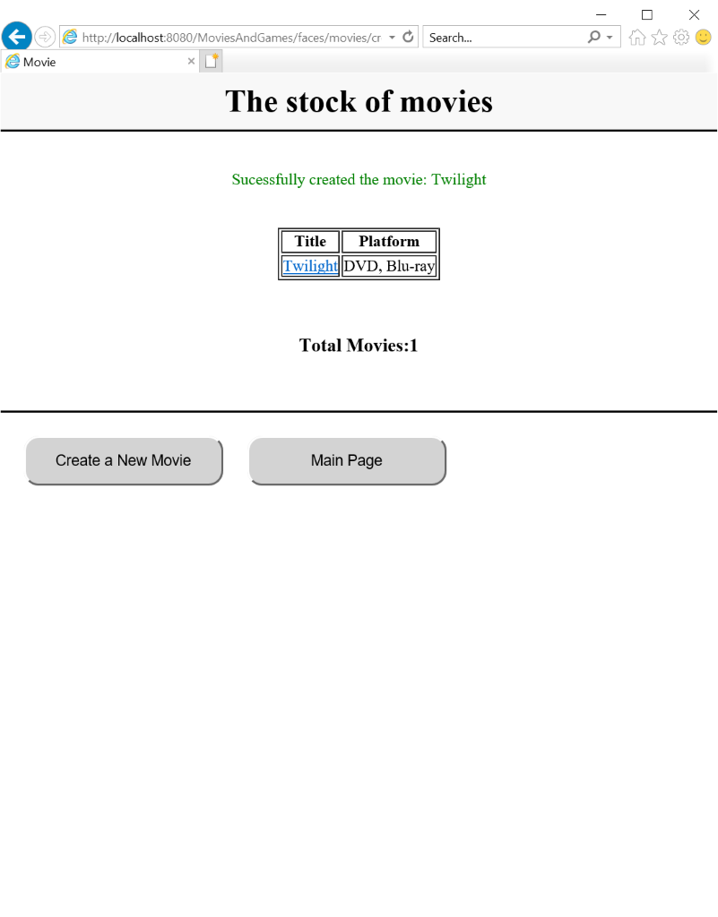

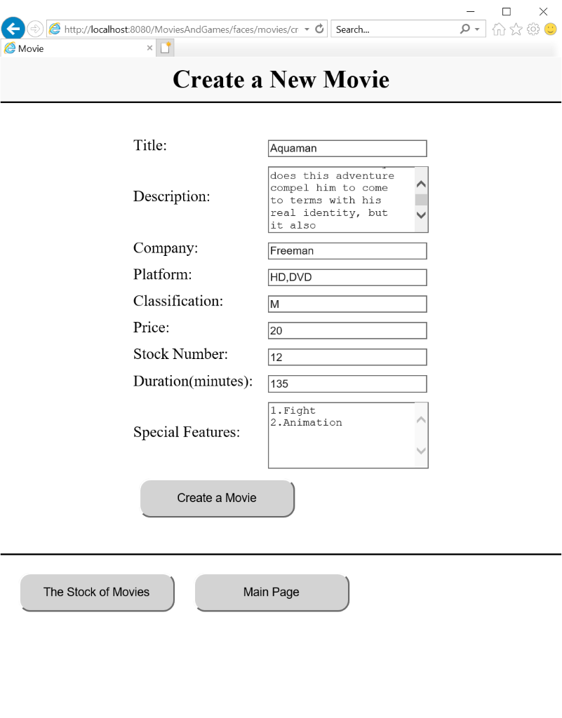

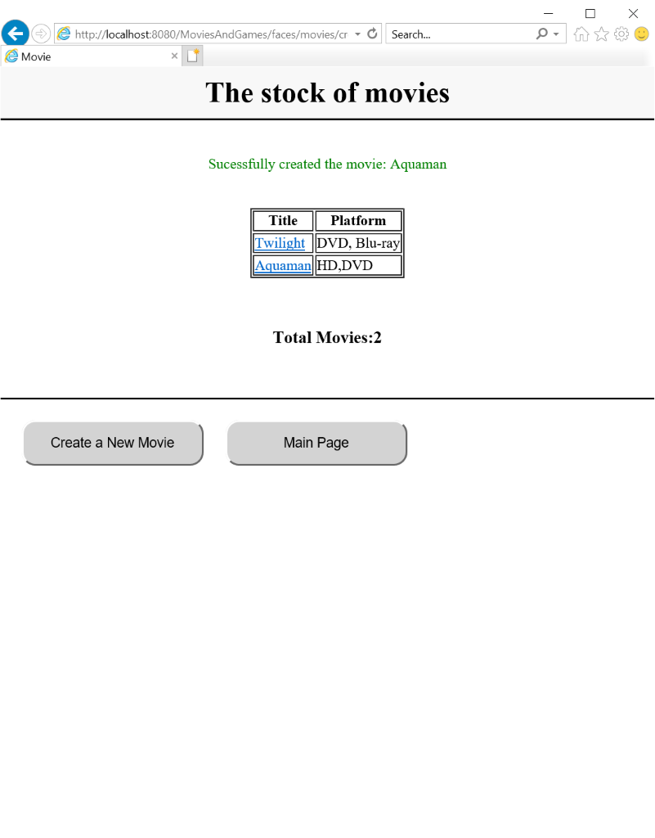

**Create 2 Games:**

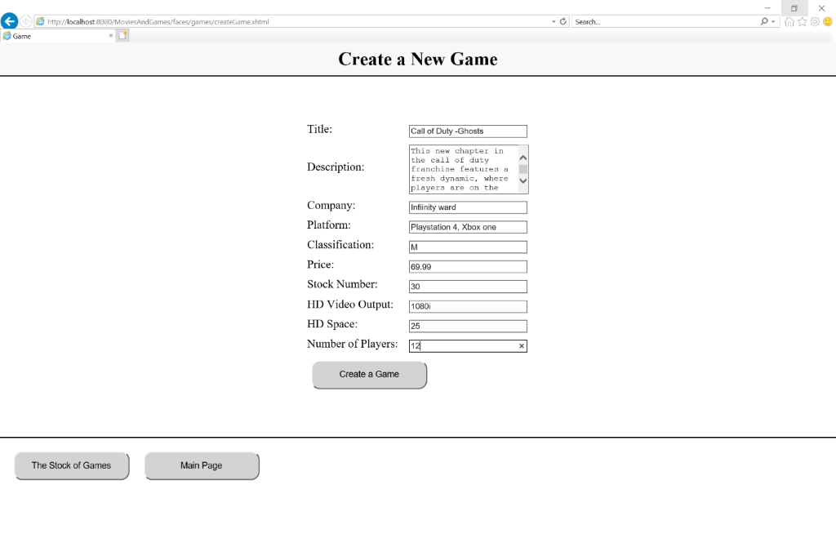

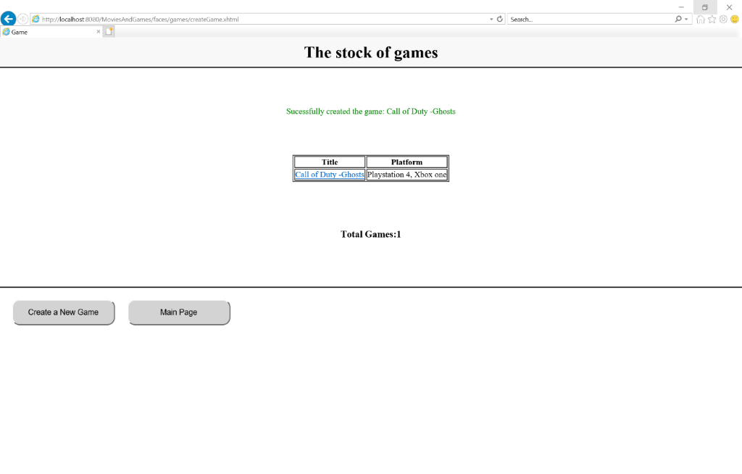

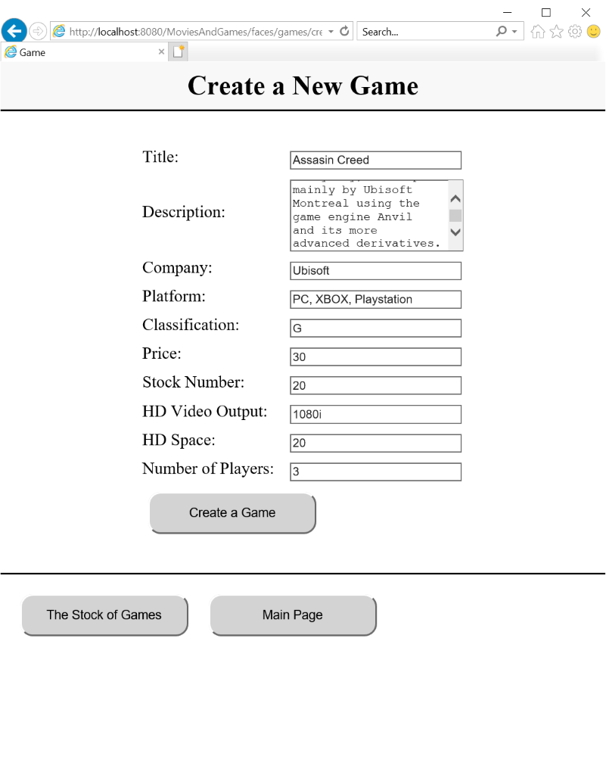

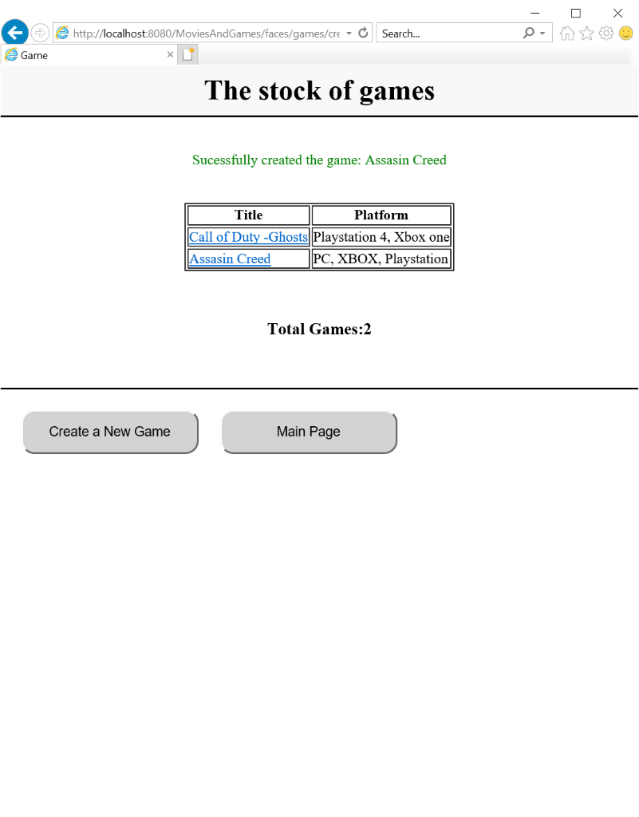

**9.Create 2 Customers**

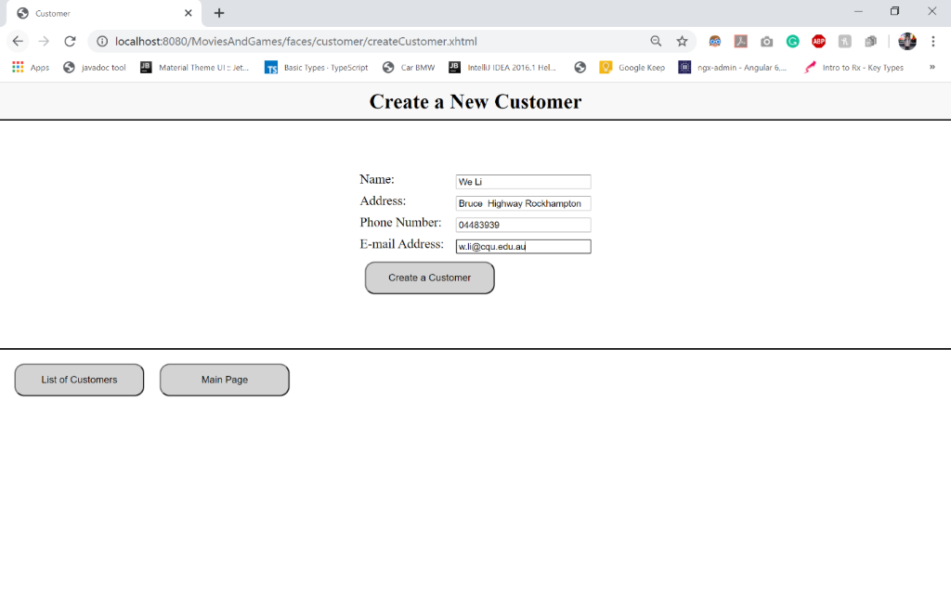

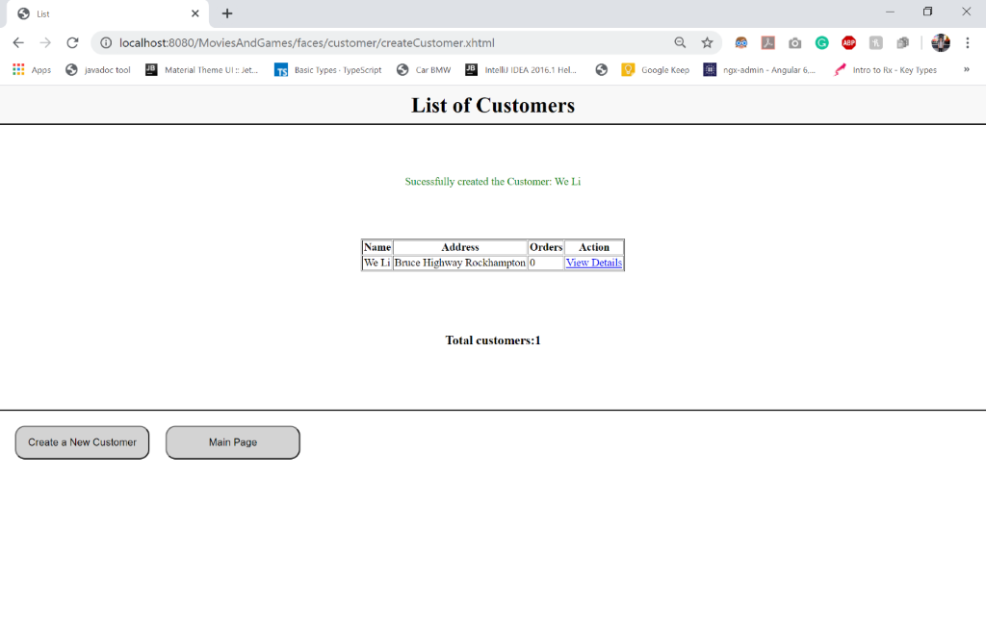

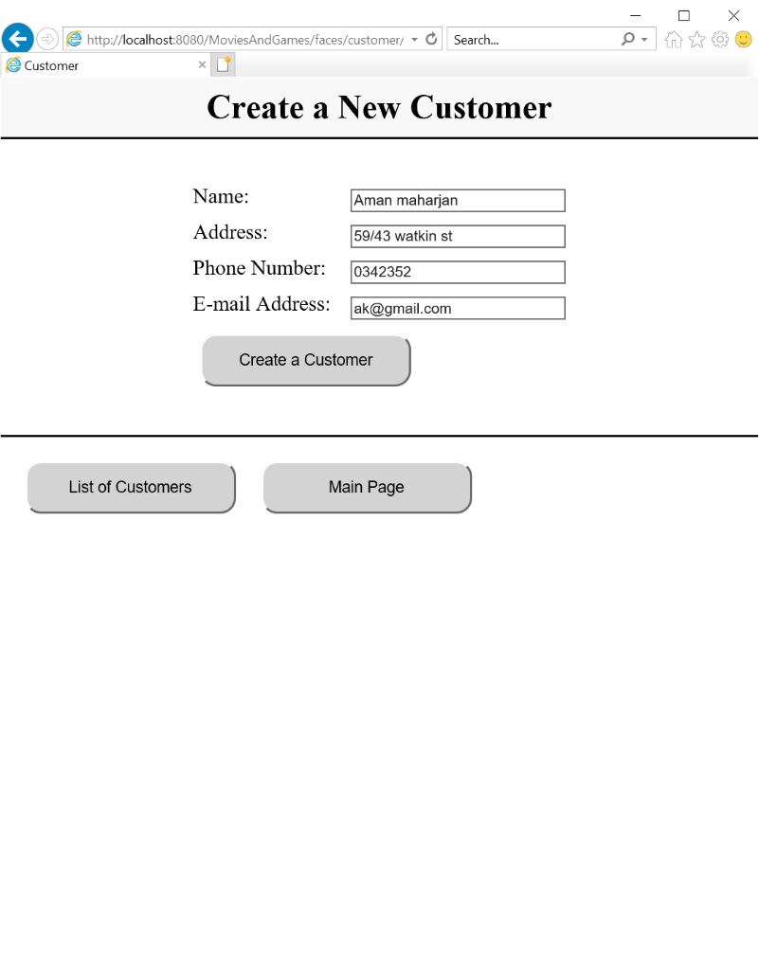

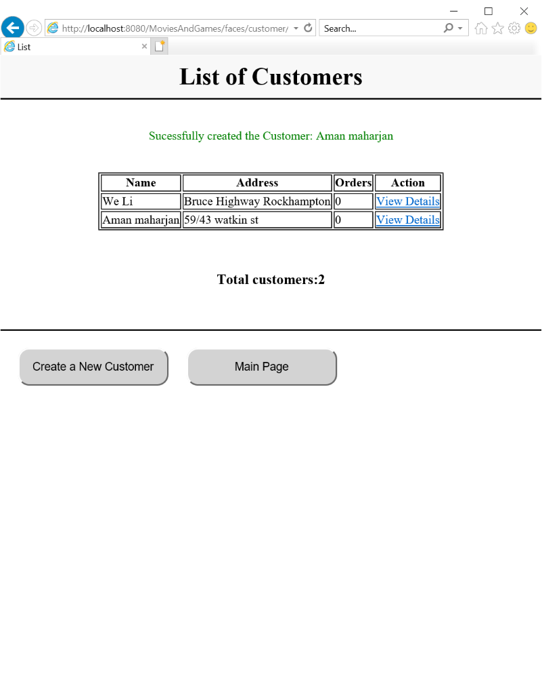

**10.Create orders**

**By customer: We Li**

Before stock of movie: 20

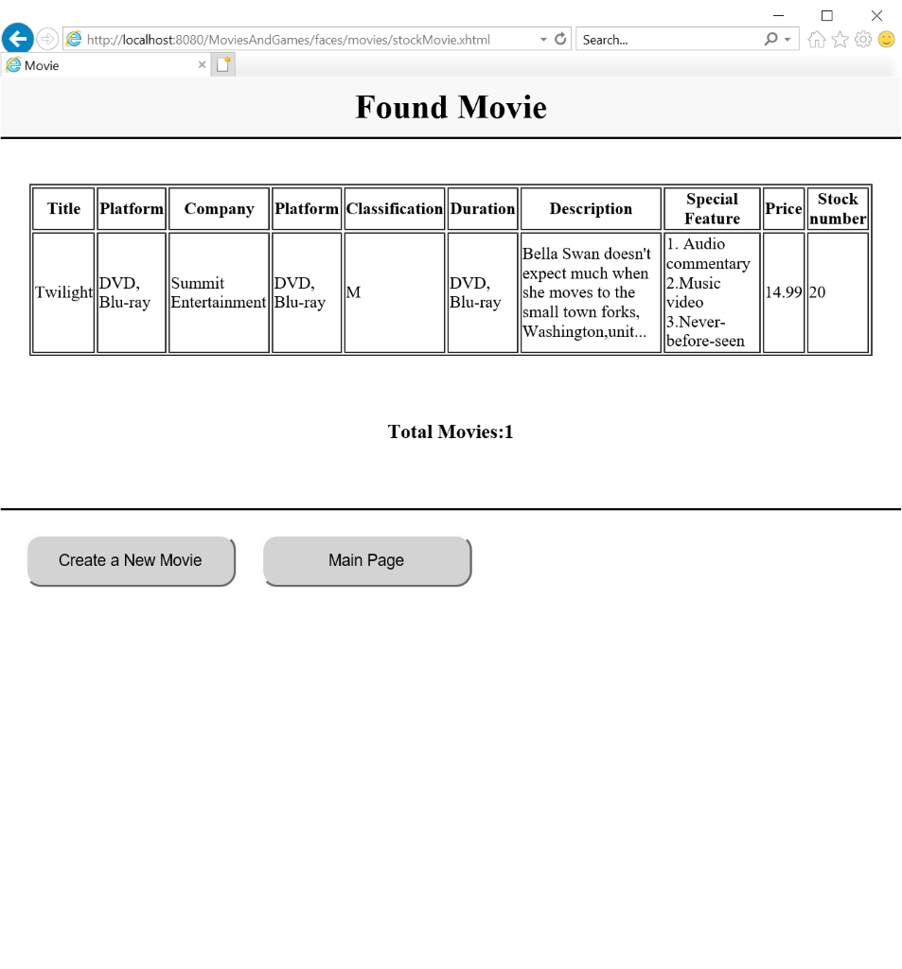

Before Stock of game: 30

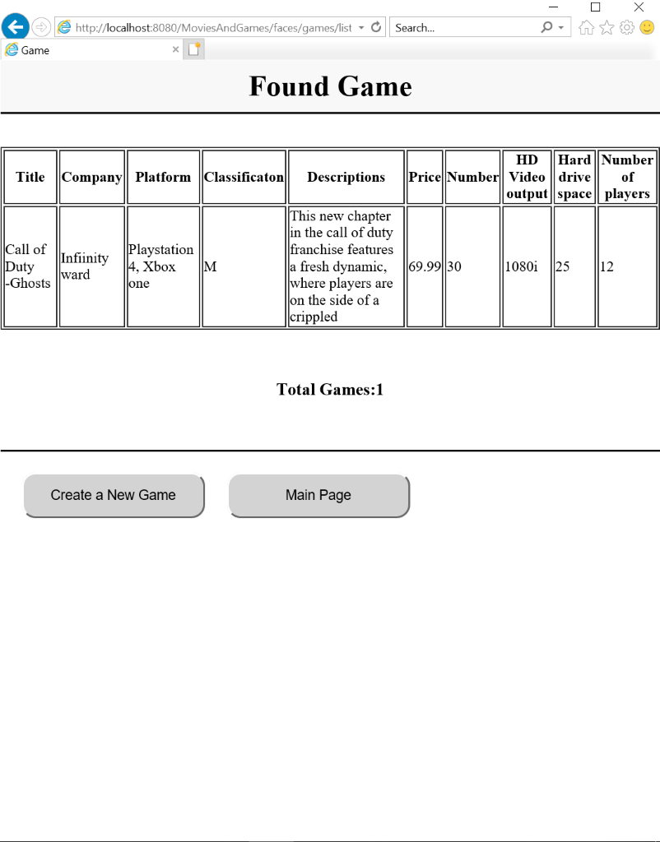

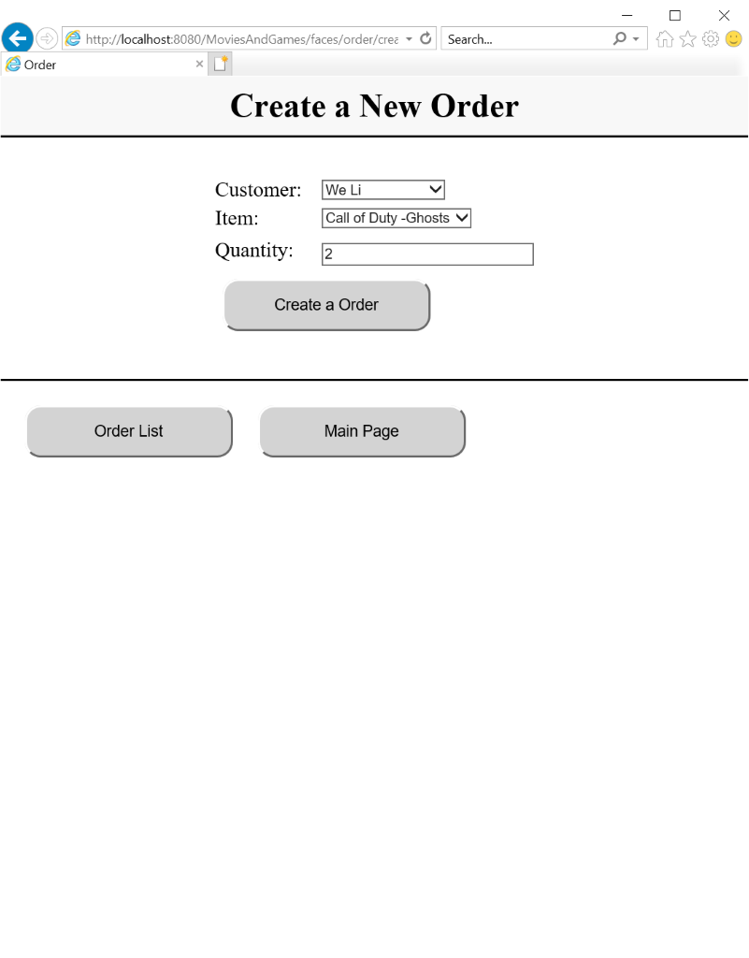

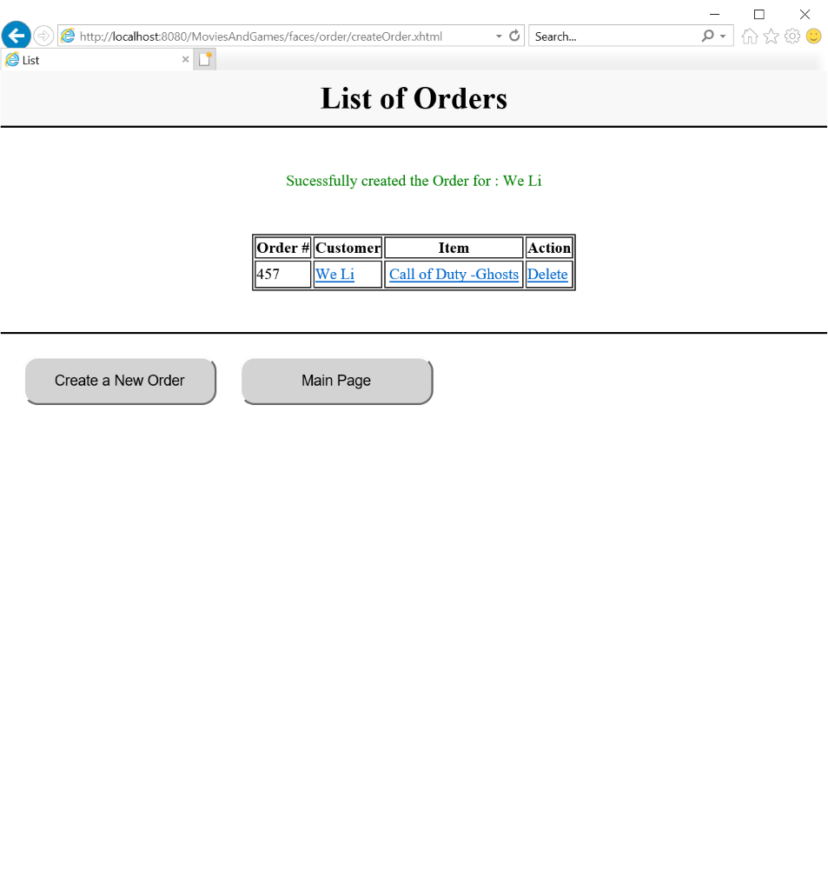

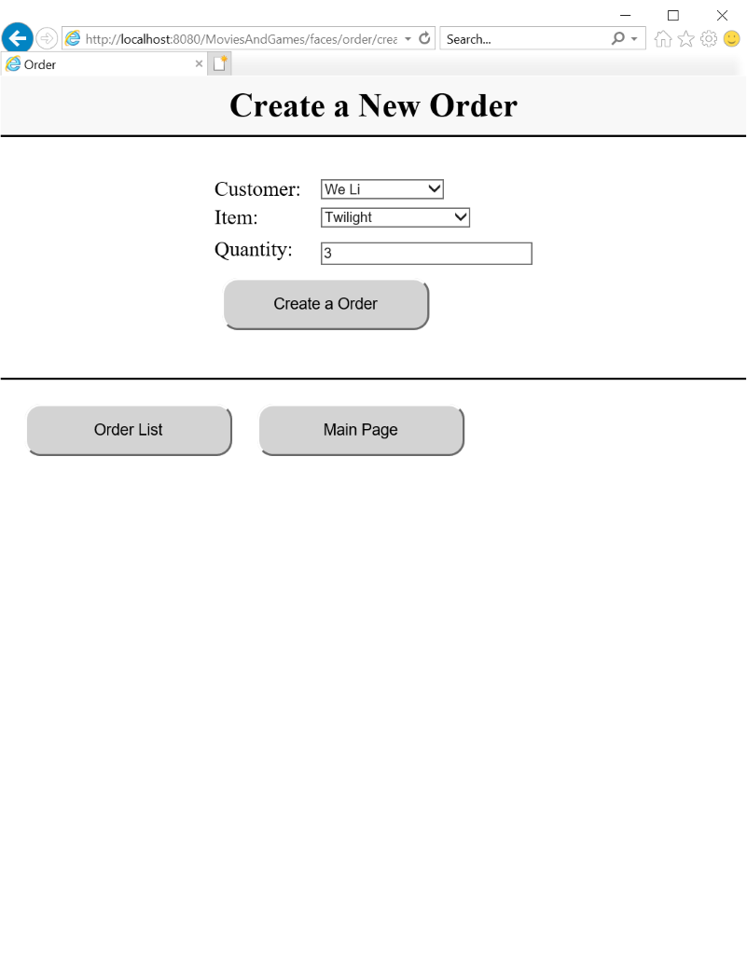

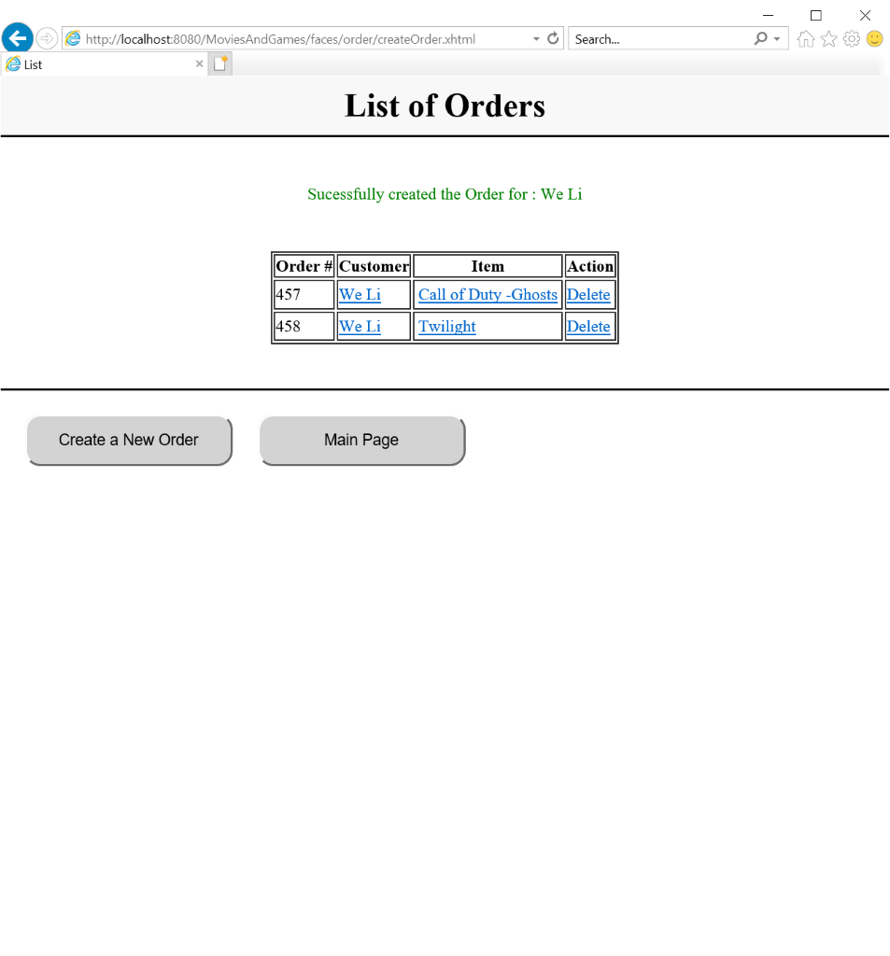

**After order:**

Stock of Movie:17

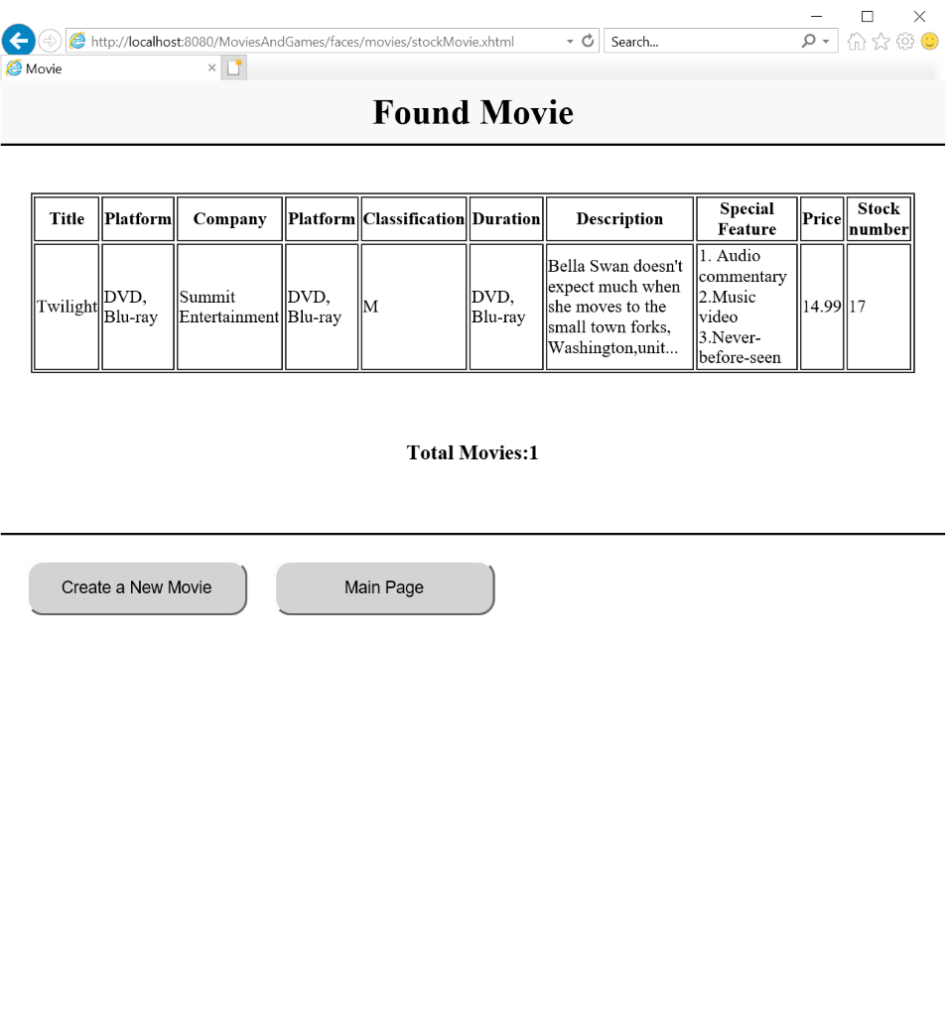

Stock of Game:28

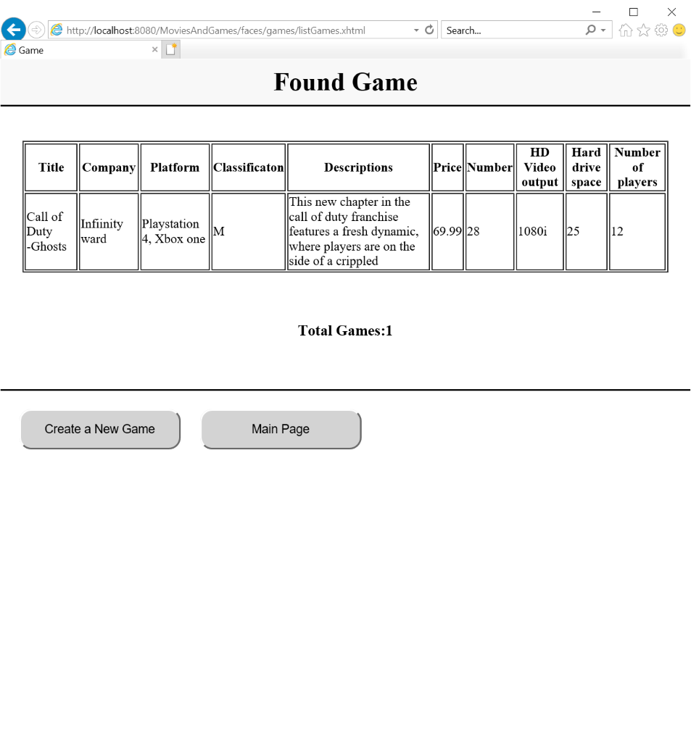

**Order by customer: Aman**

Stock of movie: 12

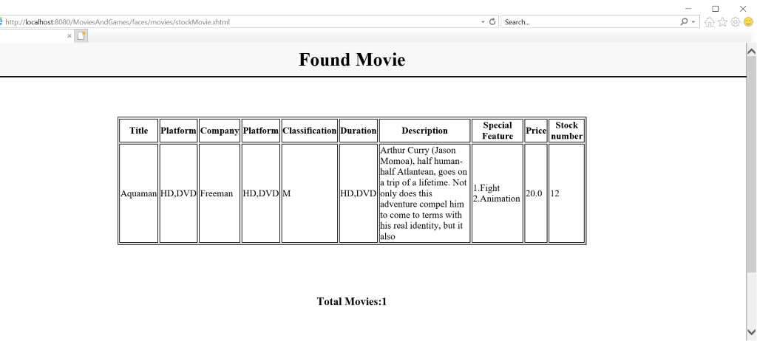

Stock of game:20

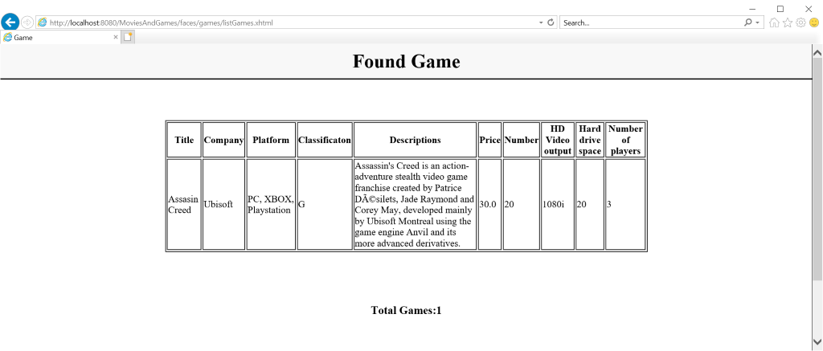

Create order

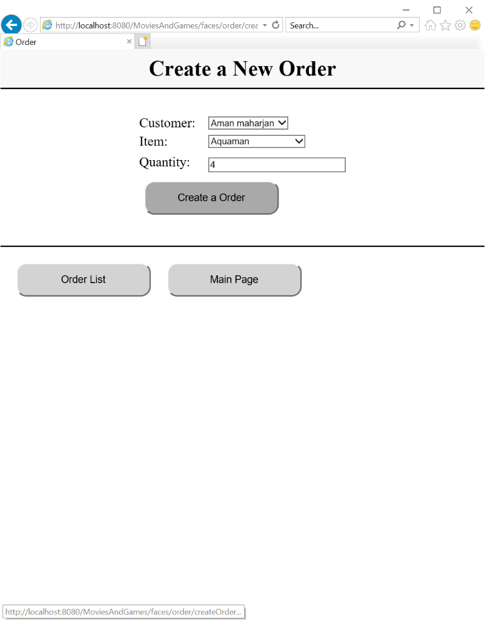

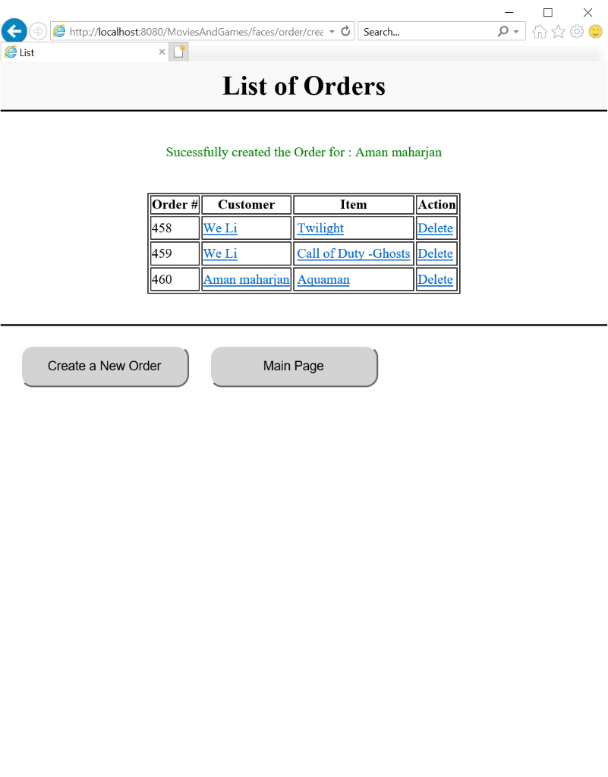

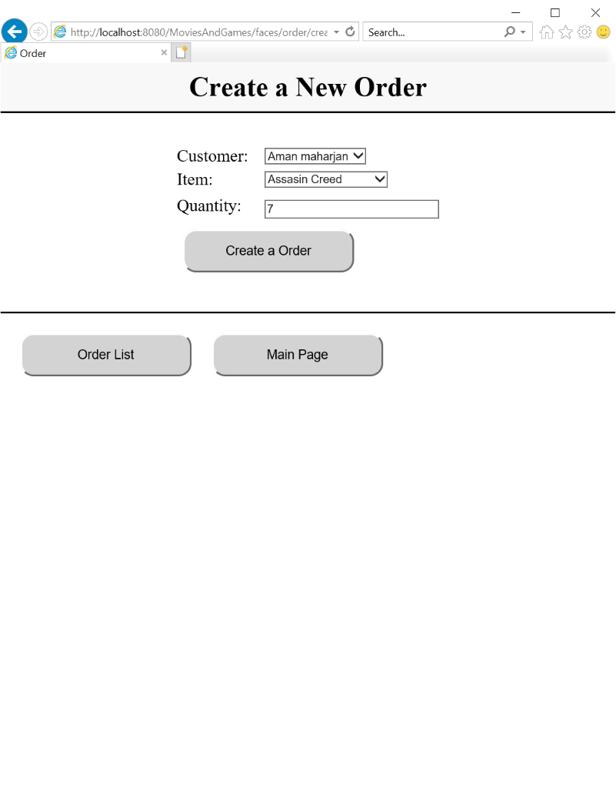

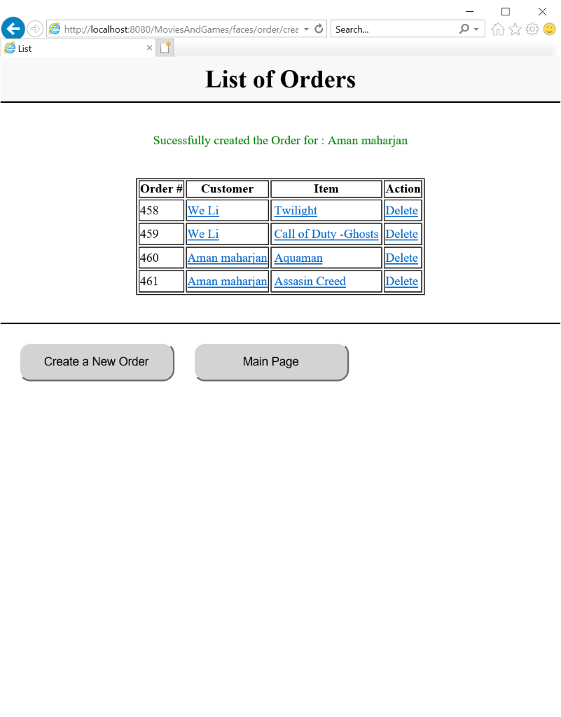

After order:

Stock of movie:8

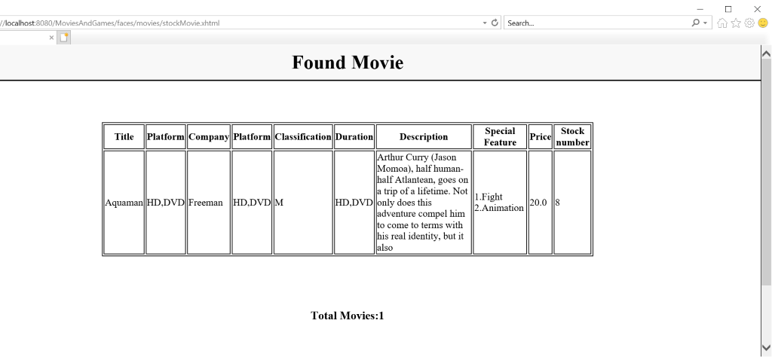

Stock of game:13

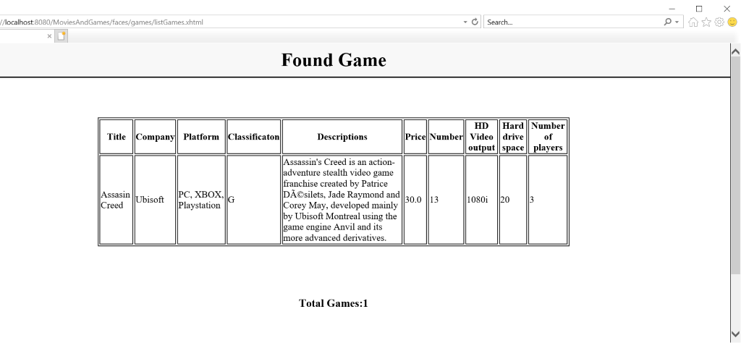

**Customer order details:**

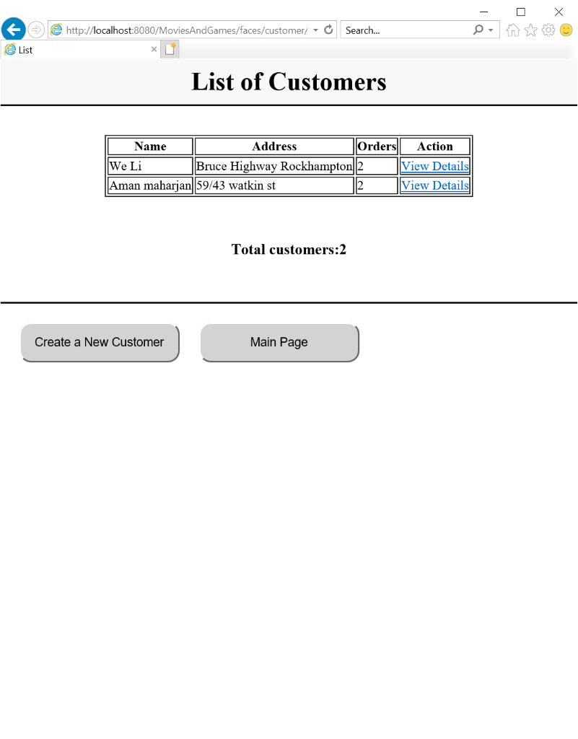

**11.Customer details:**

